TITLE: **Create a website using Canva/Webflow**

NAAN MUDHALVAN GROUP ID : NM2023TMID03556

TEAM MEMBERS:

1.PRIYADHARSHINI.R (TEAM LEADER) : (Reg.no:810020106068)

2. PRIYADARSHINI.V : ( Reg.no:810020106067)

3.RAJAJI.S : ( Reg.no:810020106072)

4.SHARMILA.R : (Reg.no:810020106081 )

INTRODUCTION:

Website creation is the process of designing, developing, and maintaining a digital platform on the World Wide Web. In the modern era, websites have become essential tools for individuals, businesses, organizations, and virtually anyone looking to establish a presence online. They serve as a digital storefront, a source of information, a means of communication, and much more. Website creation involves a combination of technical skills, creativity, and strategic planning to bring a virtual space to life.

PROJECT OVERVIEW:

DETAILS:

BRAND NAME: INFINITY TEES

CATEGORY: Clothing Brand

TARGET AUDIENCE: All (Men,Women and Kids)

EMAIL: [infinityteesclothing@gmail.com](mailto:infinityteesclothing@gmail.com)

ABOUT:

At Infinity Tees, we are more than just a clothing brand. We are a reflection of your unique style, a source of confidence, and a statement of individuality. Our journey is rooted in a passion for fashion and a commitment to quality.

This website is all about our brand Infinity tees which is founded by a team of dedicated fashion enthusiasts, we've curated a collection that embodies the latest trends, timeless classics, and sustainable choices. We believe that clothing should not only make you look good but also feel good. That's why we prioritize comfort, quality, and responsible sourcing in every piece we create.

Discover the latest trends, experience exceptional quality, and be part of a movement that cares. Explore our collection today and become a part of the INFINITY TEES family.

STEPS TO CREATE A WEBSITE:

1. Header:

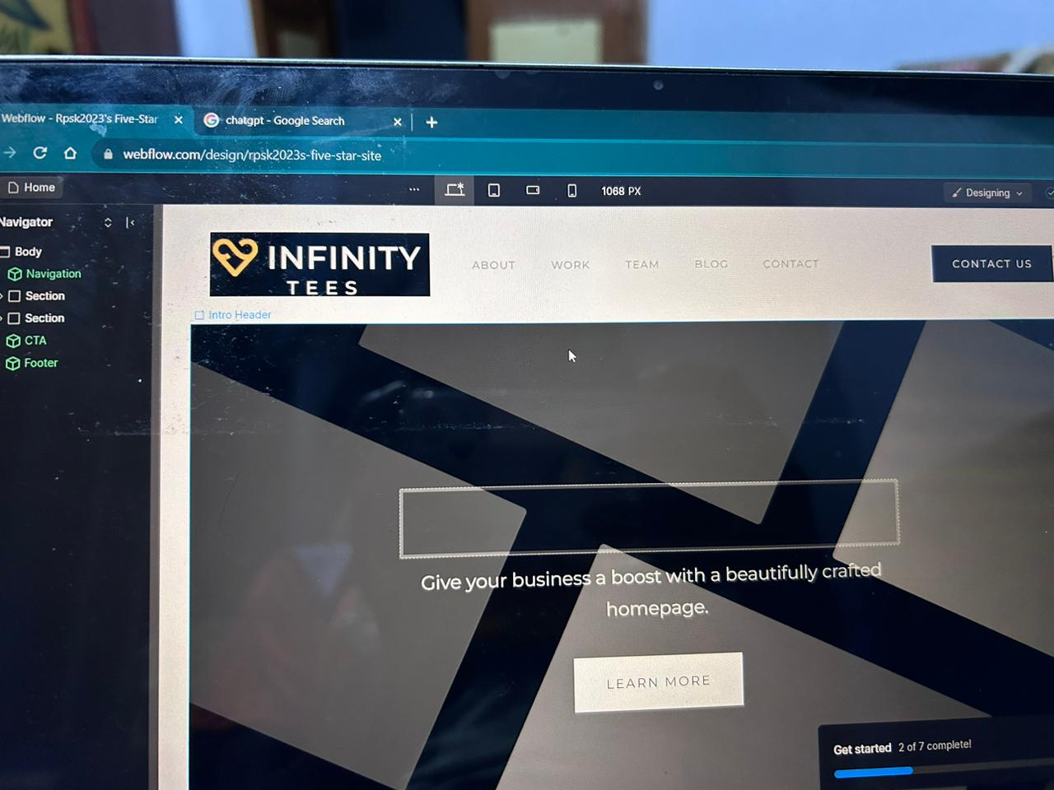

Logo and Branding: Place your brand logo prominently for brand recognition.

Navigation Menu: Include a clear and concise navigation menu for easy site navigation.

Contact Information: If applicable, add contact details like phone number or email.

1. Hero Section:

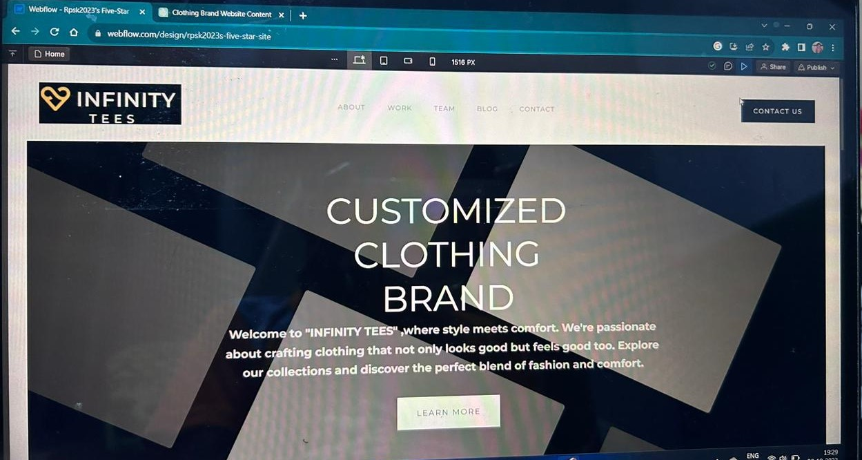

Background Image/Video: Engaging visuals that capture attention.

Headline: A clear and compelling headline introducing your brand or key message.

Call-to-Action (CTA): Encourage users to take a specific action

1. About Us Section:

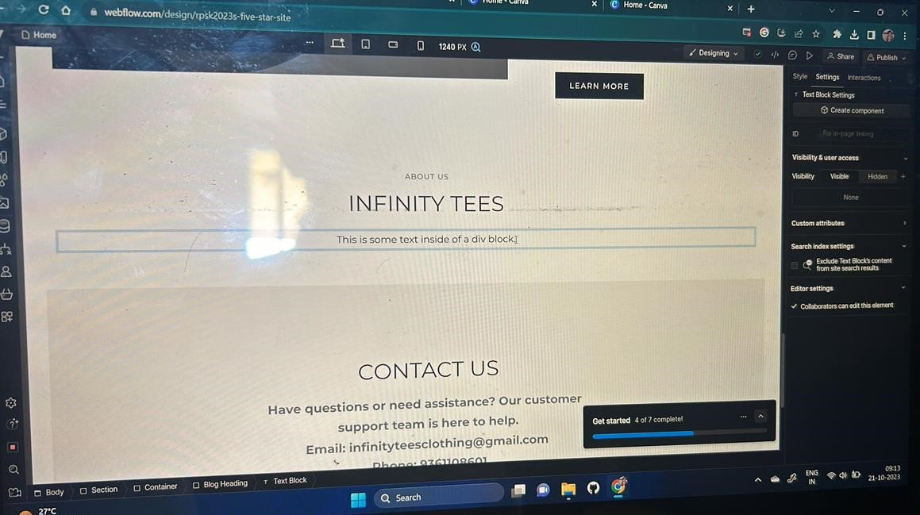

Brand Story: Share a brief but compelling story about your brand's history and values.

Mission and Vision: Clearly state your brand's mission and vision.

Team Introduction: If applicable, introduce key team members with photos and roles.

1. Services/Products Section:

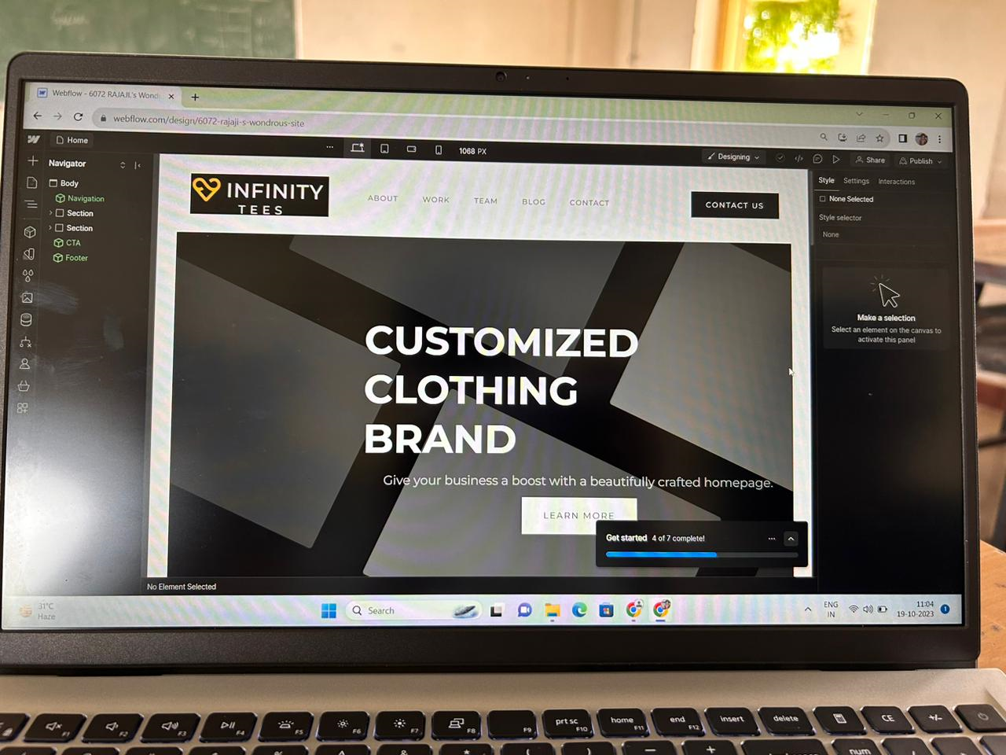

Grid or List of Offerings: Display your main products or services with images and brief descriptions.

CTAs for Each Service/Product: Encourage users to explore more details or make a purchase.

1. Features/Benefits Section:

List of Key Features: Highlight the key features or benefits of your products/services.

Visual Icons or Images: Use visuals to complement each feature or benefit.

6. Testimonials Section:

Customer Reviews: Showcase positive testimonials or reviews from satisfied customers.

Customer Photos: If available, include photos of customers using your products or services.

Gallery/Portfolio Section:

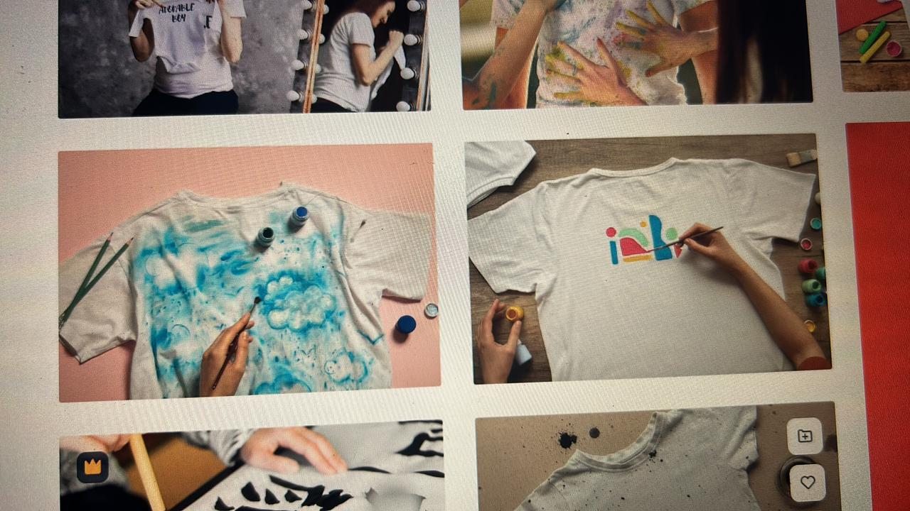

Image Grid or Carousel: Display a collection of high-quality images showcasing your work or products.

Blog/News Section:

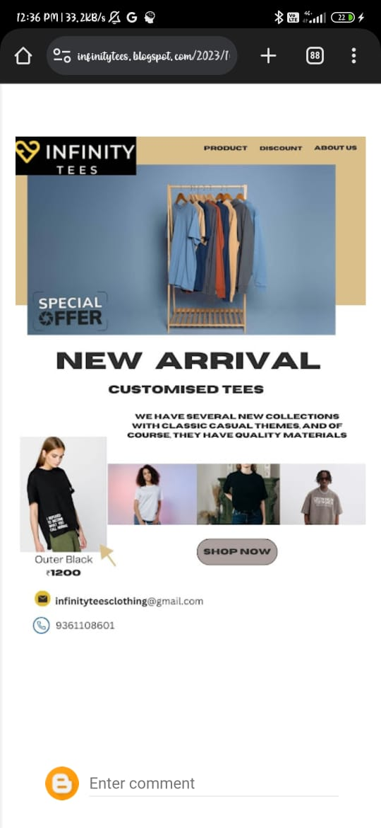

Latest Articles or News: Highlight recent blog posts or news articles.

Read More CTAs: Encourage users to explore more articles.

9. Contact Section: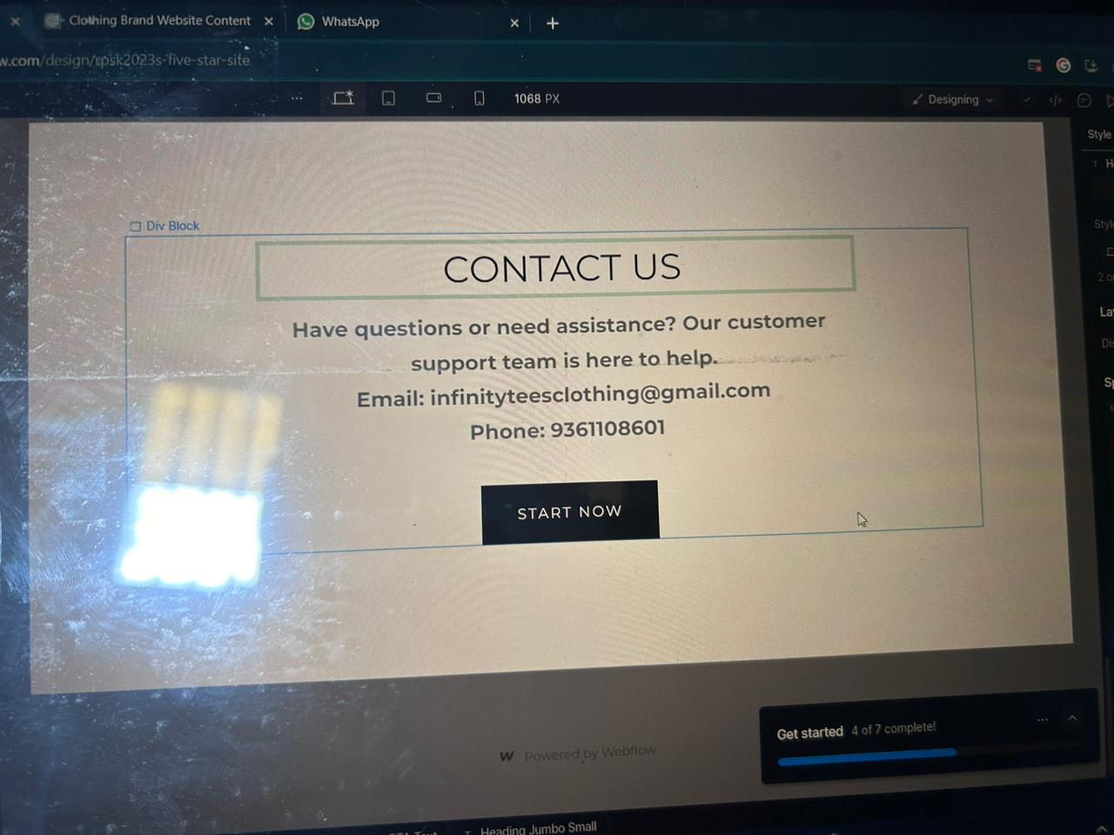

Contact Form: Include a user-friendly contact form for inquiries.

Map: Embed a map if you have a physical location.

Contact Information: Repeat essential contact details for quick reference.

10. Footer:

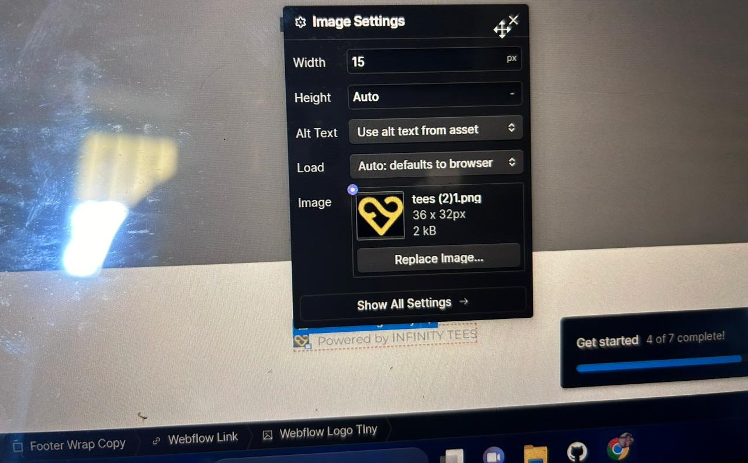

Copyright Information: Display the copyright notice for your website.

12. Dynamic Content Sections:

Featured Products or Services: Dynamically showcase new or popular items.

Latest Blog Posts: Display a snippet of your most recent blog posts.

13. Legal/Policies Section:

Privacy Policy and Terms of Service Links: Include links to important legal pages.

CONCLUSION:

Our clothing brand website is a well-designed, user-friendly, and visually appealing platform that effectively showcases the brand's products and engages visitors. It successfully combines aesthetics with functionality, providing a pleasant shopping experience. To maintain and improve its performance, ongoing monitoring and updates are recommended, along with a continued focus on user feedback and emerging web design trends. This website serves as a valuable asset in the brand's digital presence and contributes to its overall success in the competitive fashion industry.

WEBSITE LINK:

<https://preview.webflow.com/preview/rpsk2023s-five-star-site?utm_medium=preview_link&utm_source=designer&utm_content=rpsk2023s-five-star-site&preview=6ed7d9e267bef5604e335a331b2b3a70&workflow=preview>